1. Activity Practice 1: Defining Layers and Responsibilities
1.1 Definition of Four Layers The ShopSphere system adopts a strict Layered Architecture organized into four logical layers to ensure separation of concerns:

Layer | Purpose / Responsibility | Output / Artifact
1. Presentation Layer (UI/API) | Handles incoming HTTP requests from the Web Customer, performs input validation, and formats the JSON response. It does not contain business logic. | Artifact: Flask Routes / Controllers (e.g., product_routes.py)
2. Business Logic Layer | Contains the core business rules of ShopSphere (e.g., checking stock availability, calculating discounts). It orchestrates data flow between the UI and Persistence layers. | Artifact: Service Classes (e.g., ProductService)
3. Persistence Layer (Data Access) | Abstracts the database interactions. It performs CRUD operations (Create, Read, Update, Delete) without exposing SQL details to upper layers. | Artifact: Repository Classes (e.g., ProductRepository)
4. Database Layer | The physical storage system responsible for persisting data. | Artifact: SQLite Database (Schema: Products table)

2. Activity Practice 2: Identifying Components (Product Catalog)
Based on the "Search & Browse Catalog" functionality defined in Lab 1, the following components are identified for implementation:
2.1 Component Identification
- Presentation Component: ProductController
  - Role: Receives GET /products requests, parses query parameters (like category or price range), calls the Service layer, and returns the product list as JSON.
- Business Component: ProductService
  - Role: Implements business logic (e.g., get_all_products()), ensures only active products are shown, and applies business rules.
- Persistence Component: ProductRepository
  - Role: Executes database queries (e.g., SELECT * FROM products) and maps the raw database rows to Product objects.

3. Activity Practice 3: Component Diagram Modeling
3.1 Logical View Diagram
The following diagram illustrates the system's static structure and component dependencies.
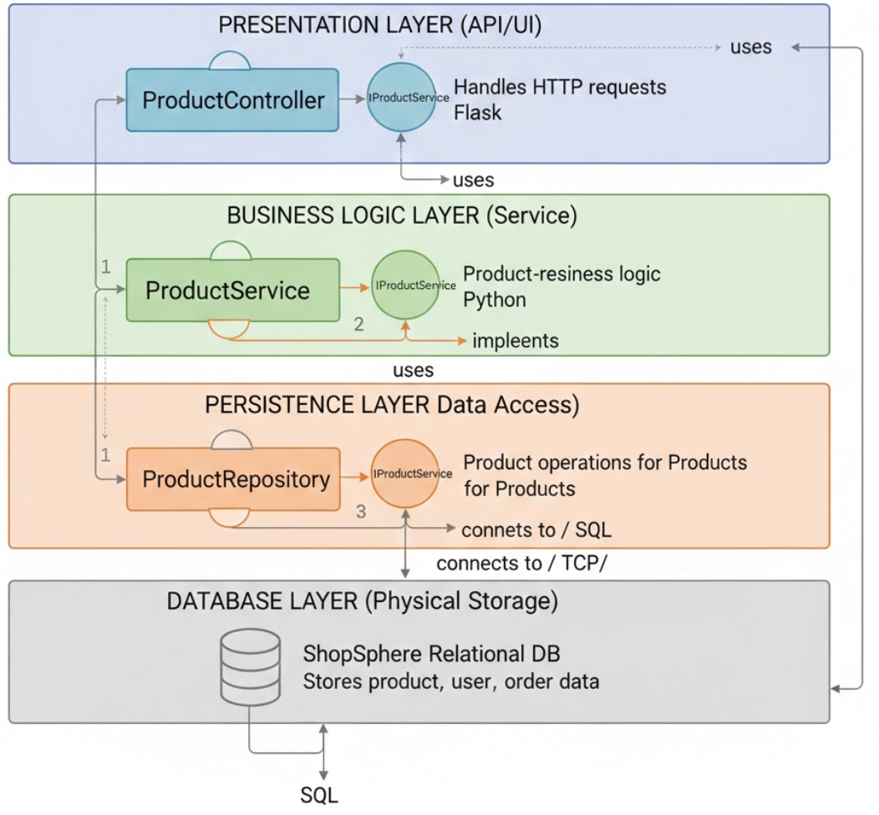
Diagram Description:
The C4 Component Diagram illustrates the internal structure of the ShopSphere Backend API using a strict 4-Layer Architecture:
- Presentation Layer (API/UI):
  - Component: ProductController.
  - Interaction: It handles incoming HTTP requests from the Web/Mobile App.
  - Dependency: It has a "uses" relationship pointing downwards to the IProductService interface in the layer below.
- Business Logic Layer (Service):
  - Component: ProductService.
  - Interaction: This component encapsulates the core domain logic (e.g., checking active status, calculating prices).
  - Interfaces:
    - It provides (implements) the IProductService interface (shown as a lollipop symbol) for the Controller to use.
    - It requires (uses) the IProductRepository interface to access data.
- Persistence Layer (Data Access):
  - Component: ProductRepository.
  - Interaction: This component abstracts the SQL logic.
  - Interfaces:
    - It provides (implements) the IProductRepository interface for the Service layer.
    - It connects directly to the underlying physical database using a database driver (e.g., via TCP/IP).
- Database Layer (Physical Storage):
  - Component: ShopSphere Relational DB.
  - Interaction: Stores physical data tables (Products, Users, Orders). It receives SQL queries from the Repository layer and returns raw data rows.
Architectural Enforcement:
The diagram demonstrates Strict Layering: Dependencies flow only downwards (Presentation $\rightarrow$ Business $\rightarrow$ Persistence $\rightarrow$ Database). This ensures that the Controller is never aware of the Database, achieving high Separation of Concerns and Modifiability.

4. Architectural Justification (Mapping from Lab 1 ASRs)
The Layered Architecture is selected to satisfy the Architecturally Significant Requirements (ASRs) identified in Lab 1:

ASR ID | ASR Description (Lab 1) | How Layered Architecture Satisfies It
ASR-1 | Security (Protect sensitive data & access control) | Security policies are centralized in the Business Logic Layer. This ensures that every request, whether from a web browser or a mobile app, must pass through the same security checks in the Service layer before accessing data.
ASR-2 | Performance (High volume browsing) | The separation of the Persistence Layer allows us to optimize database queries or implement caching (e.g., Redis) within the Repository without changing the Presentation Layer code, maintaining high performance for the Product Catalog.
ASR-3 | Availability (Cart state persistence) | The strict separation allows the Database Layer to be managed independently. We can implement database replication or failover strategies to ensure data availability without rewriting the application logic in the upper layers.

